1. ReactJS-HOL

Create a new React Application with the name “myfirstreact”, Run the application to print “welcome to the first session of React” as heading of that page.

code:

PS C:\Users\lenovo> node -v V22.17.0

PS C:\Users\lenovo> npm -v 10.9.2

PS C:\Users\lenovo> npx create-react-app myfirstreact PS C:\Users\lenovo\myfirstreact> npm start

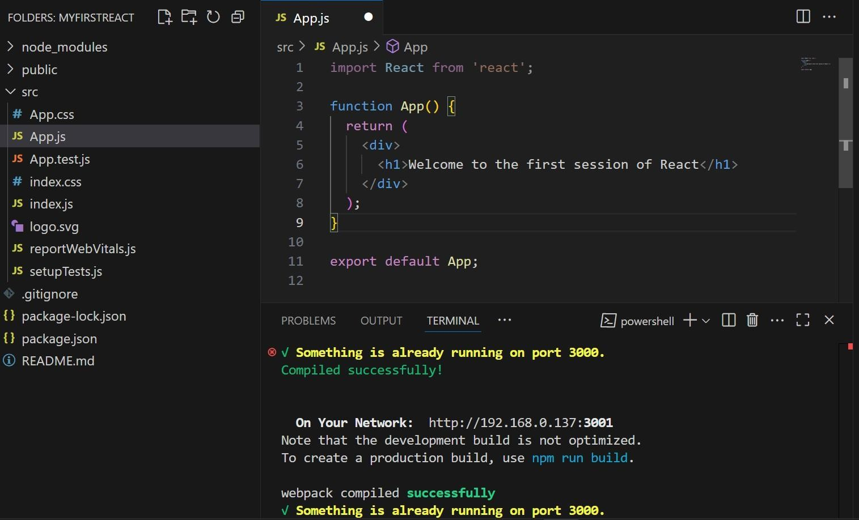

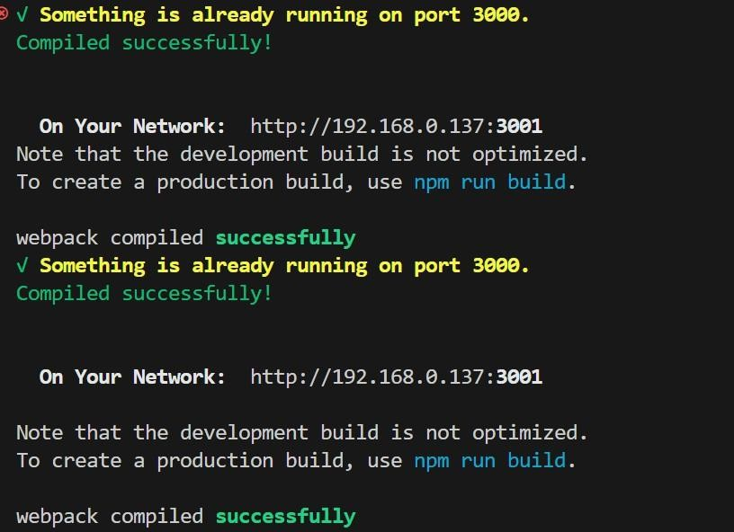

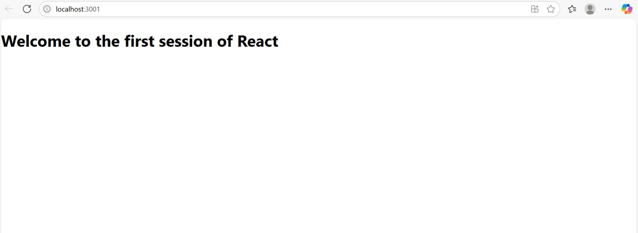OUTPUT: